**Lucrare de laborator Nr.3**

**1. Imagini**

**Creaţi o pagină web care va afişa următoarea pagină web.**

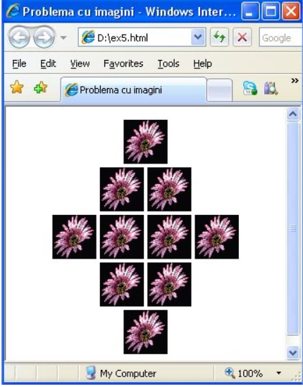

<!DOCTYPE html>

<html>

<head >

<title>Laborator nr.3</title>

</head >

<body align="center">

<img src="1.jpg" height="100" weight="100">

<br>

<img src="1.jpg" height="100" weight="100">

<img src="1.jpg" height="100" weight="100">

<br>

<img src="1.jpg" height="100" weight="100">

<img src="1.jpg" height="100" weight="100">

<img src="1.jpg" height="100" weight="100">

<img src="1.jpg" height="100" weight="100">

<br>

<img src="1.jpg" height="100" weight="100">

<img src="1.jpg" height="100" weight="100">

<br>

<img src="1.jpg" height="100" weight="100">

<br>

</body>

<html>

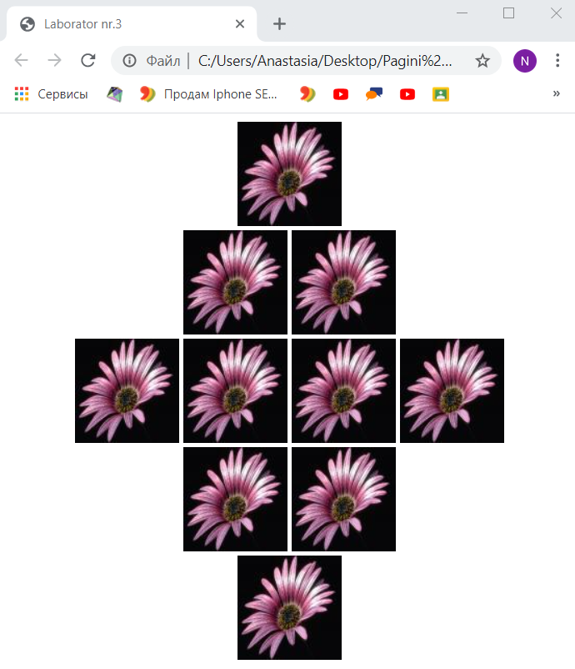

**2.Tabele**

**Creaţi o pagină web care va afişa următorul tabel:**

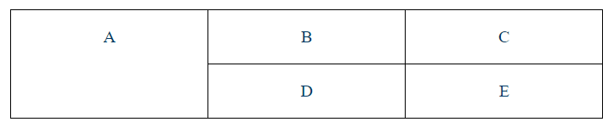

<!DOCTYPE html>

<html>

<table border=1 width="500" height="100" align="center" >

<tr>

<th rowspan="2">A</th>

<th>B</th>

<th>C</th>

</tr>

<tr>

<th>D</th>

<th>E</th>

</tr>

<

</table>

</html>

